# IGBT and diode power losses

In our drive, we are using a 2 levels inverter to supply an asynchronous motor. During the operation there are losses on the semiconductors, which are responsible for heating. In order to maintain secure and optimal operation, we have to make sure, these temperatures don’t exceed the maximum value. Firstly, we have to clarify the types of the power losses. There are two main types of them: Static Losses and Switching Losses. We can distribute both of the, to two other groups as shown on the first figure:

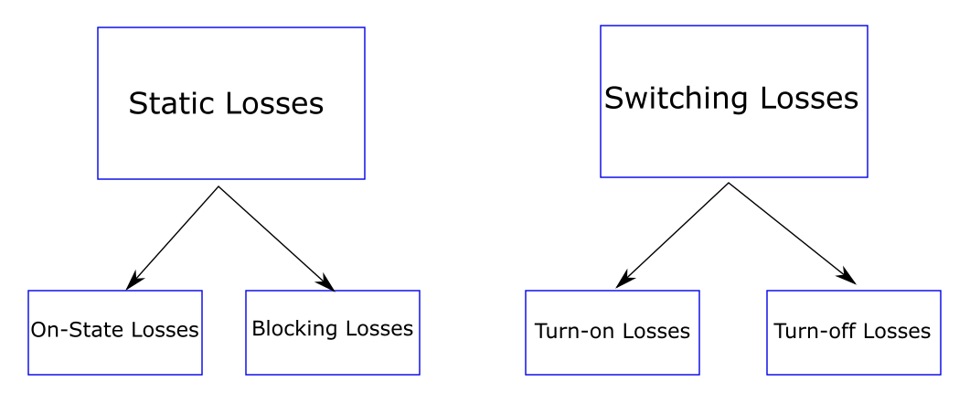

In our application the maximum blocking voltage stays well under 1kV, so we can negligible the blocking loss. So the total losses will be look like: $P_{tot}=P_{cond}+P_{switching}$. We will distinguish the losses of the diode and the IGBT. We can use the equations from the SEMICRON handbook 1. The following equations will be implemented in the calculating program:

* $P_{cond(IGBT)}=\left(\frac{1}{2π}+\frac{m*cosφ}{8}\right)*V_{CE0}(T_{j})*{\overset{^}{I}}_{1}+\left(\frac{1}{8}+\frac{m*cosφ}{3π}\right)*r_{CE}(T_{j})*{{\overset{^}{I}}_{1}}^{2}$ for the conduction losses of the IGBT
* $P_{cond(Diode)}=\left(\frac{1}{2π}-\frac{m*cosφ}{8}\right)*V_{F0}(T_{j})*{\overset{^}{I}}_{1}+\left(\frac{1}{8}-\frac{m*cosφ}{3π}\right)*r_{F}(T_{j})*{{\overset{^}{I}}_{1}}^{2}$ for the conduction losses of the Inverse Diode
* $P_{sw(IGBT)}=f_{sw}*(E_{on}+E_{off})*\frac{\sqrt{2}}{π}*\frac{I_{out}}{I_{ref}}*{\left(\frac{V_{cc}}{V_{ref}}\right)}^{K_{v}}*(1+TC_{Esw}*(T_{j}-T_{ref}))$ for the switching losses of the IGBT
* $P_{sw(IGBT)}=f_{sw}*E_{rr}*\frac{\sqrt{2}}{π}*{\left(\frac{I_{1}}{I_{ref}}\right)}^{K_{i}}*{\left(\frac{V_{cc}}{V_{ref}}\right)}^{K_{vd}}*\left(1+TC_{Err}*\left(T_{j}-T_{ref}\right)\right)$ for the switching losses of the Inverse Diode

Where $m=\frac{{\overset{^}{V}}_{out1}}{\frac{V_{d}}{2}}$ is the modulation index ( ${\overset{^}{V}}_{out1}$ is the amplitude of the fundamental harmonic of the phase voltage to neutral, $V_{d}$ is the DC Link voltage), $cosφ$ is taken from the motor’s datasheet, $V_{CE0},r_{CE},V_{F0},r_{F},I_{ref},V_{ref},E_{on},E_{off},E_{rr}$ are taken from the semiconductors datasheet, $K_{v},K_{i},K_{vd},T_{Esw},T_{Err}$ are constants (average values given by the handbook), $T_{j}$ is the junction temperature of the semiconductor, $f_{sw}$ is the switching frequency of the modulation, $V_{cc}$ is the actual DC Link voltage and $I_{out}$ is the inverter output current ( ${\overset{^}{I}}_{1}$ is the amplitude of $I_{out}$). We can calculate $V_{cc}$ by assuming a 3-phase bridge rectifier. Then the DC voltage is computed as follows: ${\overset{^}{V}}_{cc}=\sqrt{2}*\sqrt{3}*\frac{3}{π}*V_{grid,phase-0}$, where $V_{grid}$, is our actual input voltage (grid voltage). The inverter output voltage is the voltage we want to apply to the motor, thus we can figure it knowing the control method. We are using V/f control, this means we are controlling the motor’s frequency by modifying the motor’s voltage. This method is linear, so fmax is reached when the applied voltage is the motor’s nominal voltage. The simple calculation looks like this: $V_{out}=V_{n}*\frac{f}{f_{max}}$. After that, we need the output current of the inverter. The motor current has a relationship with the torque applied to the shaft (Ms). We can divide the motor’s current (Iout) vector into two components which are perpendicular to each other. One of them will be responsible for the motor’s flux (Id), and the other one for the torque (Iq). The control is trying to keep the flux constant by keeping Id constant and influencing the torque by modulating Iq. The sum of the squares always equals the motor’s current and Id being constant, the only thing which changes the motor’s current is Iq. So, if we know the actual torque on the shaft, we can then calculate the torque current, because the following equation stands: $I_{q}=I_{n}*\left(\frac{M_{s}}{M_{n}}\right)*cos(φ_{n})$, where $M_{n}$ and $cos(φ_{n})$ are the nominal values of the motor. First, we calculate the nominal values of the current components. At the nominal operating point $I_{qn}=I_{n}*cos(φ_{n})$ and from that $I_{d}=\sqrt{{I_{n}}^{2}-{I_{qn}}^{2}}$, which will be a constant due to the flux permanency. After we know the nominal values we can compute the current for any operating point below the nominal frequency (in the constant flux range). Finally combining the formulas we get: $I_{out}=\sqrt{{I_{d}}^{2}+{\left[I_{n}*\left(\frac{M_{s}}{M_{n}}\right)*cos(φ_{n})\right]}^{2}}$.